1. What have I done so far?

* I created the UI for the Registrar Dashboard (Calendar). This includes the Title, Calendar, Back/Next/Add Event Buttons.

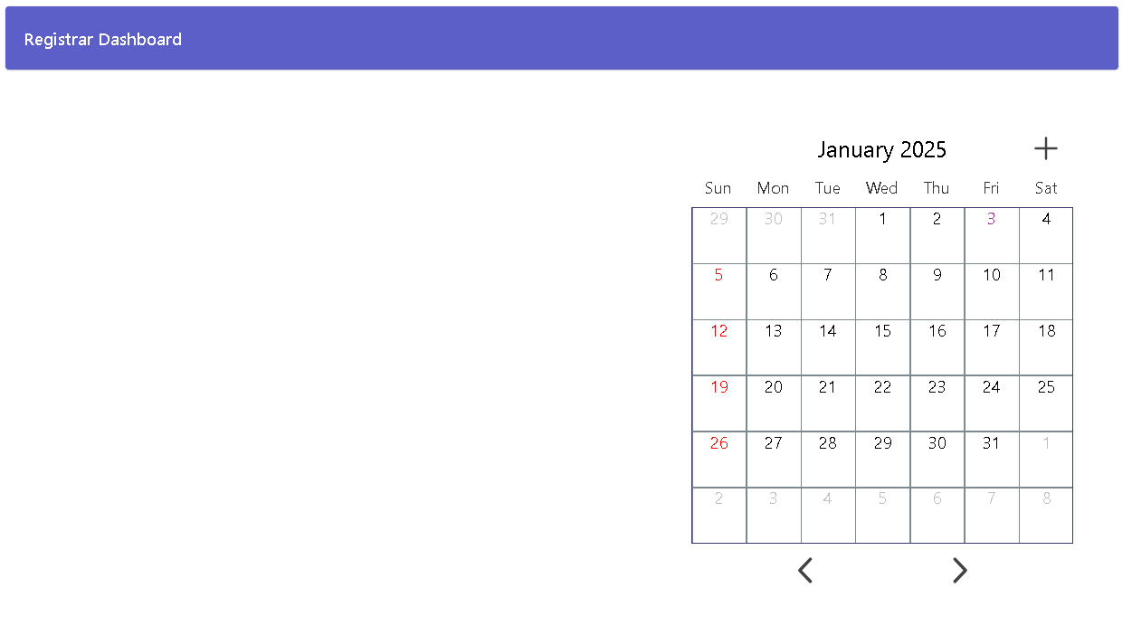

* For the backend, I coded the back and next buttons to change the layout of the calendar depending on the month and year. I also made it so that clicking on a date will show the event screen for that day.

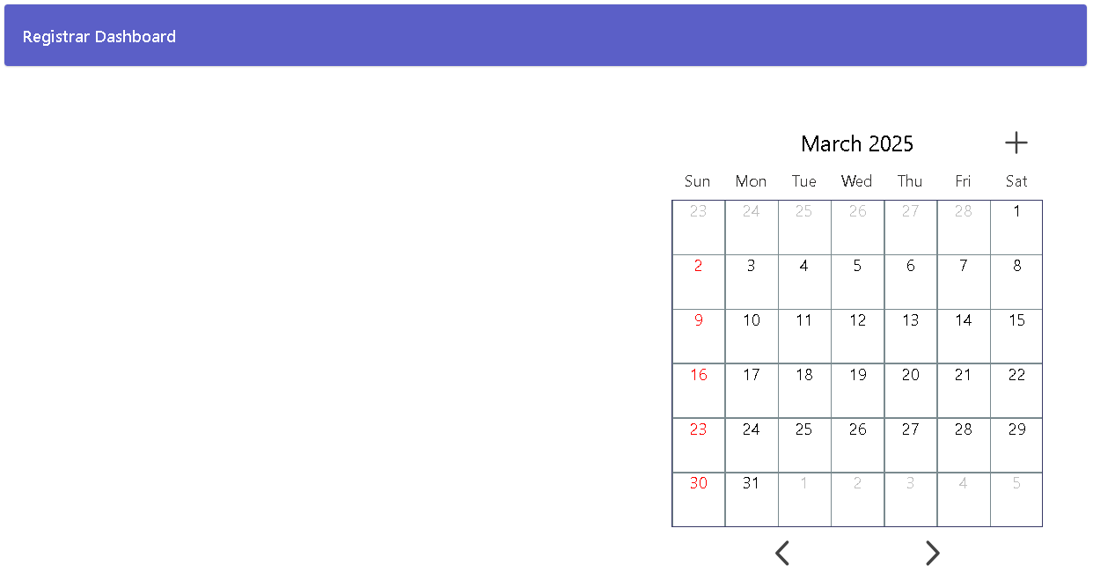

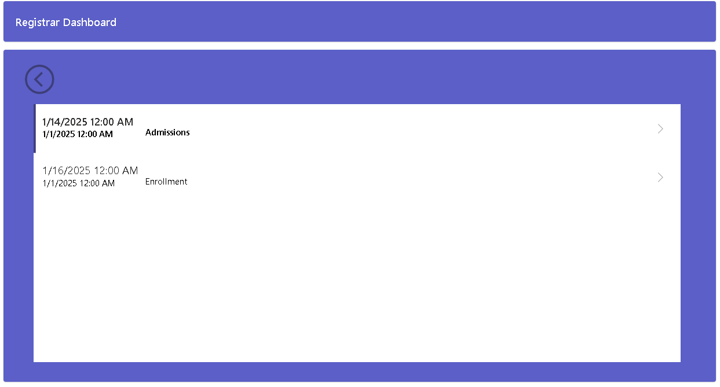

1. What will I do next?

* I will add the Legends Area and Placeholder for Color Coded Dates (connected to legends).
* I will add the functionality for the Add Event Button.
* I will make it so that Legends will dynamically update whenever an event with certain tags has been created.

1. What challenges did I face?

I had trouble completing other assigned tasks because I had to wait for other members to finish their tasks that are connected to mine. I also had issues in configuring the visibility of the ‘no events today’ page.